**Nested For loop**

Nested For loop means placing a for loop statement inside another for loop statement.

Nested loop has 4 types are shown in this page: [Nested loop types.docx](Nested%20loop%20types.docx)

Nested loops have the ability to create patterns as shown here: [Create patterns with nested loops.docx](Create%20patterns%20with%20nested%20loops.docx)

There are 2 cases for nested for loop.

1. Loops with same max value (same ending point).
2. Loops with different max value (same ending point).

**Firstly**: **Loops with same max value (same ending point).**

This type consist of more than for loop statements all have the same value of the ending point (n) placed inside each other. You can know the total number of statements that going to be printed by (n) number of for loops.

**Assume** that we have a statement consist of 3 for loop with n = 5 then the total number of statements that going to be printed is (5)3 = 125

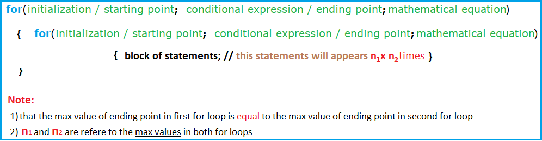

**How for loop keyword works?**

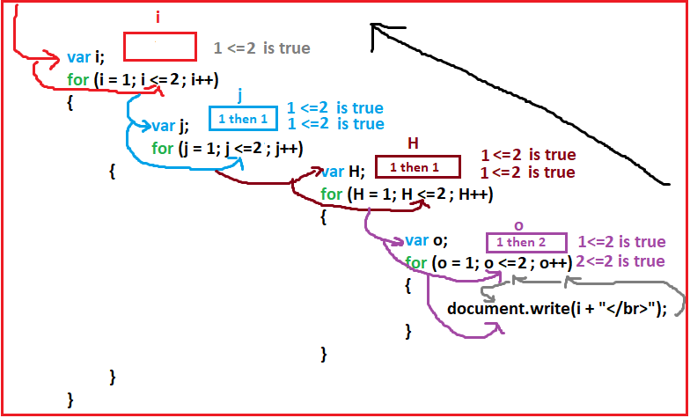

**Example1:**

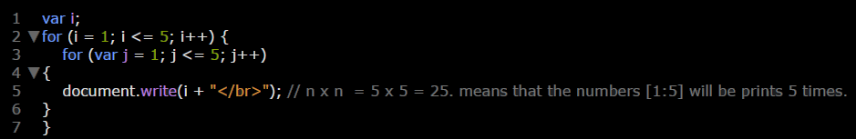

**Example2:**

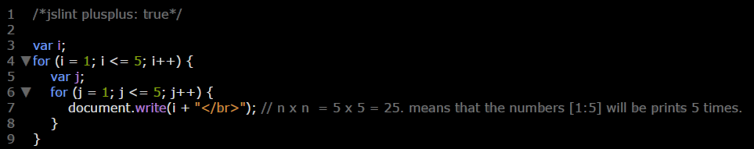

**Example3:**

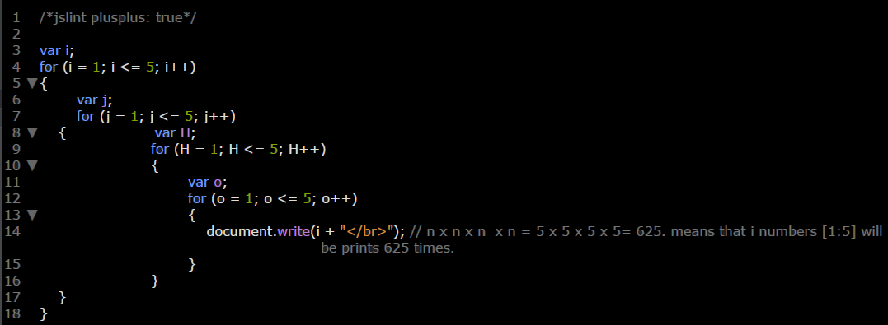

**Secondly**: **Loops with different max value (differ ending point).**

This type consists of more than for loop statements with different values of the ending point (n) placed inside each other. You can know the total number of statements that going to be printed by (n1*n2*n3*n4….).

**Assume** that we have a statement consist of 3 for loop with n1 = 5, n2 = 3, and n3= 4 then the total number of statements that going to be printed is (5*3*4)= 60

**Example 1:**

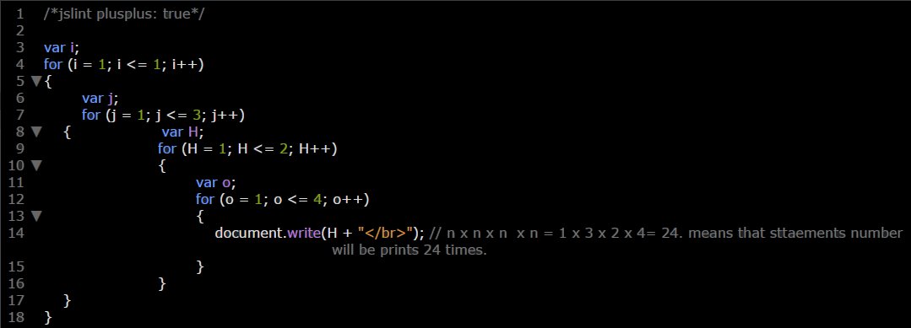

**Example 3:**

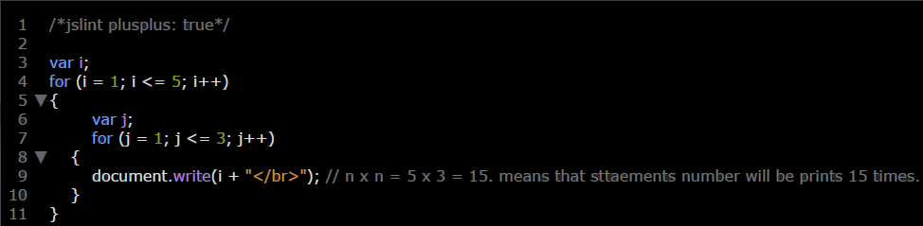

**Example 4:**

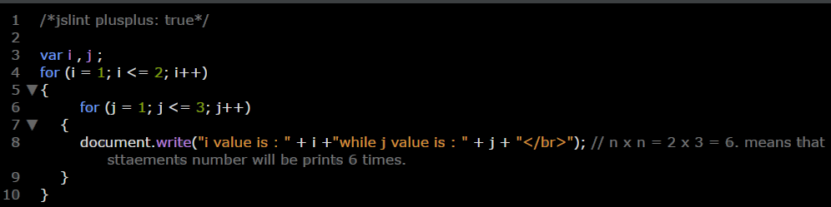

**Note:** Label can be determine for any loop (for loop, while loop, do while loop, and for in loop) to distinguishes it from the other loops.

**Example:**

